1-Listen and Circle:
2nd grade (unit 1 )

Salwa Tala Amir Adam

1 4 9 7






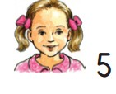
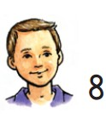






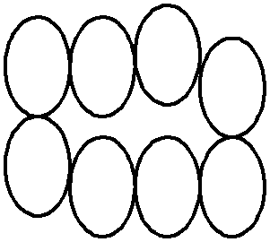
2-Complete the dialogue:

Jamila Zaid

Hi, Zaid. ……………….Jamila. What's your ………………? My name's Zaid. How …………….are you ? I,m seven.
Bye. ……………………

name Hi Bye old

3- Write:

1 ……… 3 ……….. 5 ………..7 ……….. 9…………

4-Count and write;

……………. …………….

5- a- How old is she?

……………………………………

b- How old is he ?

……………………………………

He's She's

6- Complete: ( S _ A _ T _ J )

…….mir ……ala …….ami …..amila

7-Write: ( A a _ Cc )

